

American International University- Bangladesh

CSC 3222: Web Technologies

CO1.1 and CO2.1 Evaluation

Project Report

Fall 19-20

Project Title: University Management System

Section: F

|  |  |
| --- | --- |
| Student Name | Student Id |
| MD.ARIFUZZAMAN JAMY | 17-35618-3 |
| BORNO, MD. SIRAJUDDIN | 18-36449-1 |
| NAZIA TAFANNUM | 18-37747-1 |
| SHAFIQ AHMED | 18-38454-2 |

Introduction:

*Write the answer of why you are doing this project? (No more than 60 words)*

*#########################################*

Background Study

As reference we chose “Varendra University” [ <http://vu.edu.bd/> ]. This is a private university with fixed credit system and we are following it’s structure for our project.

Requirement Analysis:

1. User Category:

There are 4-types of Users here. They are:

* Admin
* Stuff
* Teacher
* Student

1. Feature List:

In this project the Admin has the following features:

* Register new teacher
* View and Edit teacher, student and stuff profile
* View System log

In this project the Stuff has the following features:

* Register new student
* Receive payment
* Setup classroom
* Notice update

In this project the Teacher has the following features:

* View Student Profile
* Upload study materials
* Upload grades

In this project the Student has the following features:

* View finance
* View grade
* Download study material
* View teacher profile

Design:

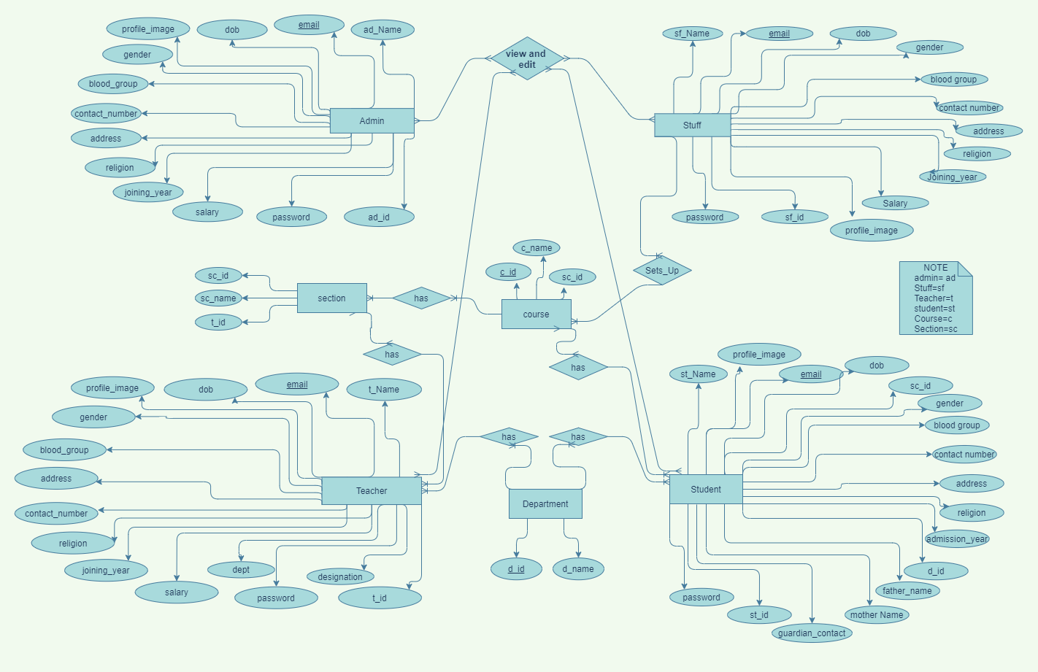

Tools Used:

To develop this project, we have used the following:

• Google Chrome

• VS code

• Xampp

• draw.io

• Adobe XD

•

System Images against the Specification:

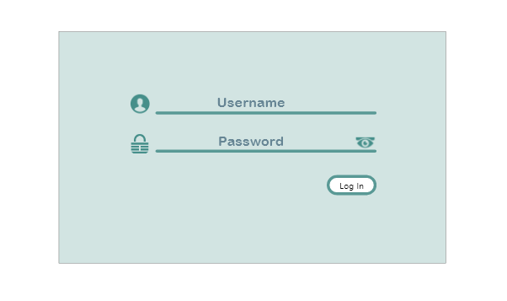 Login: All user will use same login page

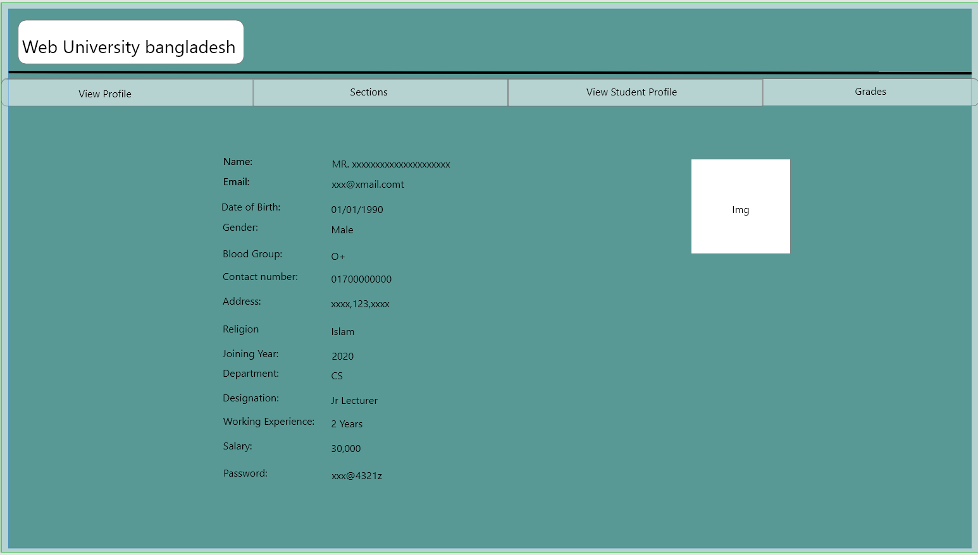

View Profile: teacher can view his profile and Edit if needed

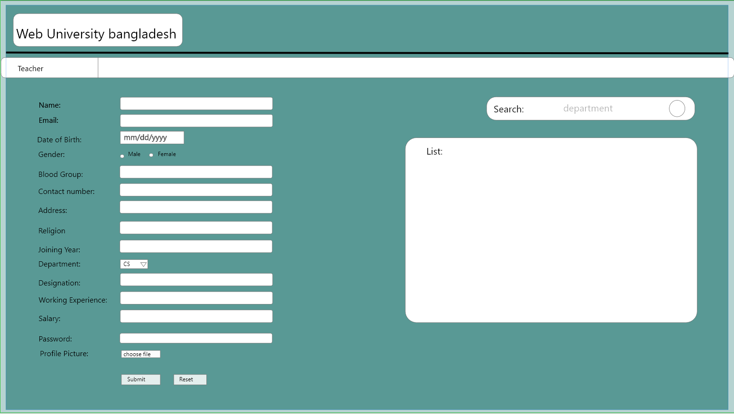

Add Teacher: Admin can register new Teacher

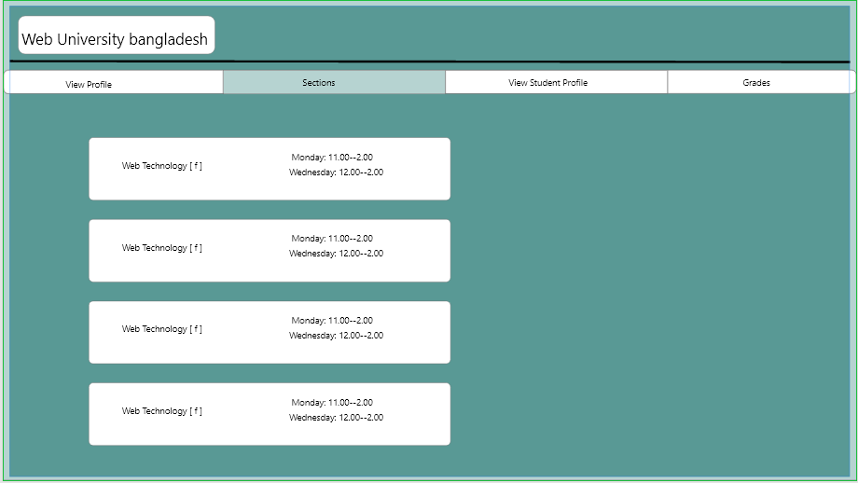

View Section: Teacher can view his assigned sections

Impact of this Project:

Describe the increasing importance of your project on modern society and environment.

How will people be benefitted from your project?

#######################################

(Maximum 80 words)

Limitations and Possible Future Improvements:

1. Deploy in online server
2. Add auto attendance
3. Online payment system

*[Note: Make sure that your report is maximum 10 pages (including cover page).*

|  |  |  |  |  |  |
| --- | --- | --- | --- | --- | --- |
| CO1.1 and CO2.1 Evaluation: Project Report Evaluation | | | | | |
| Project Proposal  (5) | Background  Study  (5) | Requirement Analysis  (5) | Entity  Diagram  (5) | System Images  against the  Specification (5) | Total (25) |
|  |  |  |  |  |  |
|  | | | | | |